Week 5 - Data Visualization
Name: Swayam Rudrawar

Objective:
The objective of this project is to visualize real-time light intensity data collected from a BH1750 light sensor. A Streamlit dashboard was developed to present sensor readings in a user-friendly format using graphs, statistical summaries and classification indicators. The dashboard helps monitor lighting conditions and analyze recorded datasets efficiently.

Components / Software Used:
- STM32 Microcontroller
- BH1750 (GY-30) Light Intensity Sensor
- Python
- Streamlit
- Pandas
- Plotly
- VS Code
- GitHub

Working Principle:
Light intensity values collected from the BH1750 sensor were stored as datasets. The Streamlit application loads the selected dataset (Bright, Dim or Dark), processes the readings, and displays interactive visualizations including a line graph, summary statistics and the current light classification.

Project Workflow:
BH1750 Sensor → STM32 → Logged Dataset (CSV) → Streamlit Dashboard → Data Visualization

Dashboard Features:
- Dataset selector (Bright / Dim / Dark)
- Current Lux value
- Maximum and Minimum Lux values
- Interactive line graph
- Dataset statistics
- Recent sensor readings
- Download dataset option
- Light classification indicator

Dashboard Screenshots:

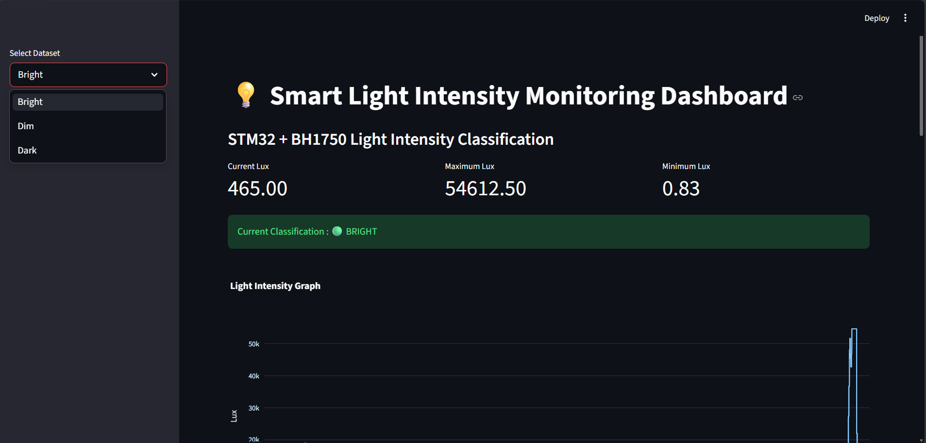
Figure 1. Main dashboard

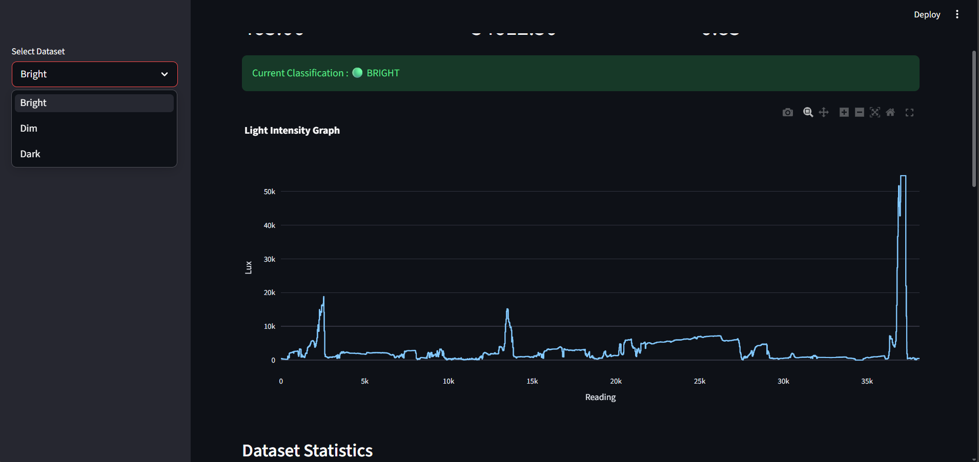
Figure 2. Line graph visualization (Bright)

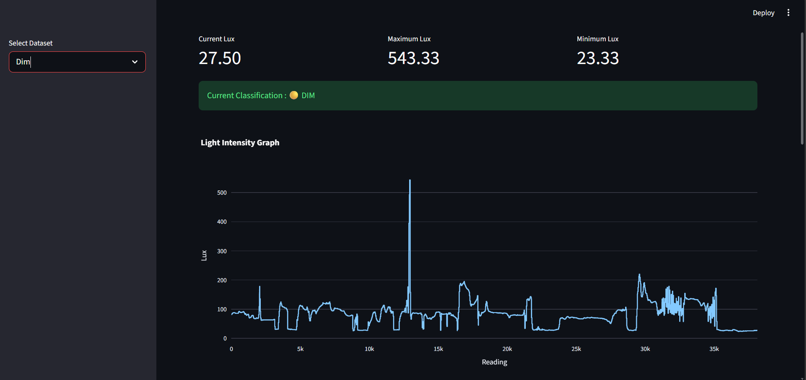
Figure 3. Line graph visualization (Dim)

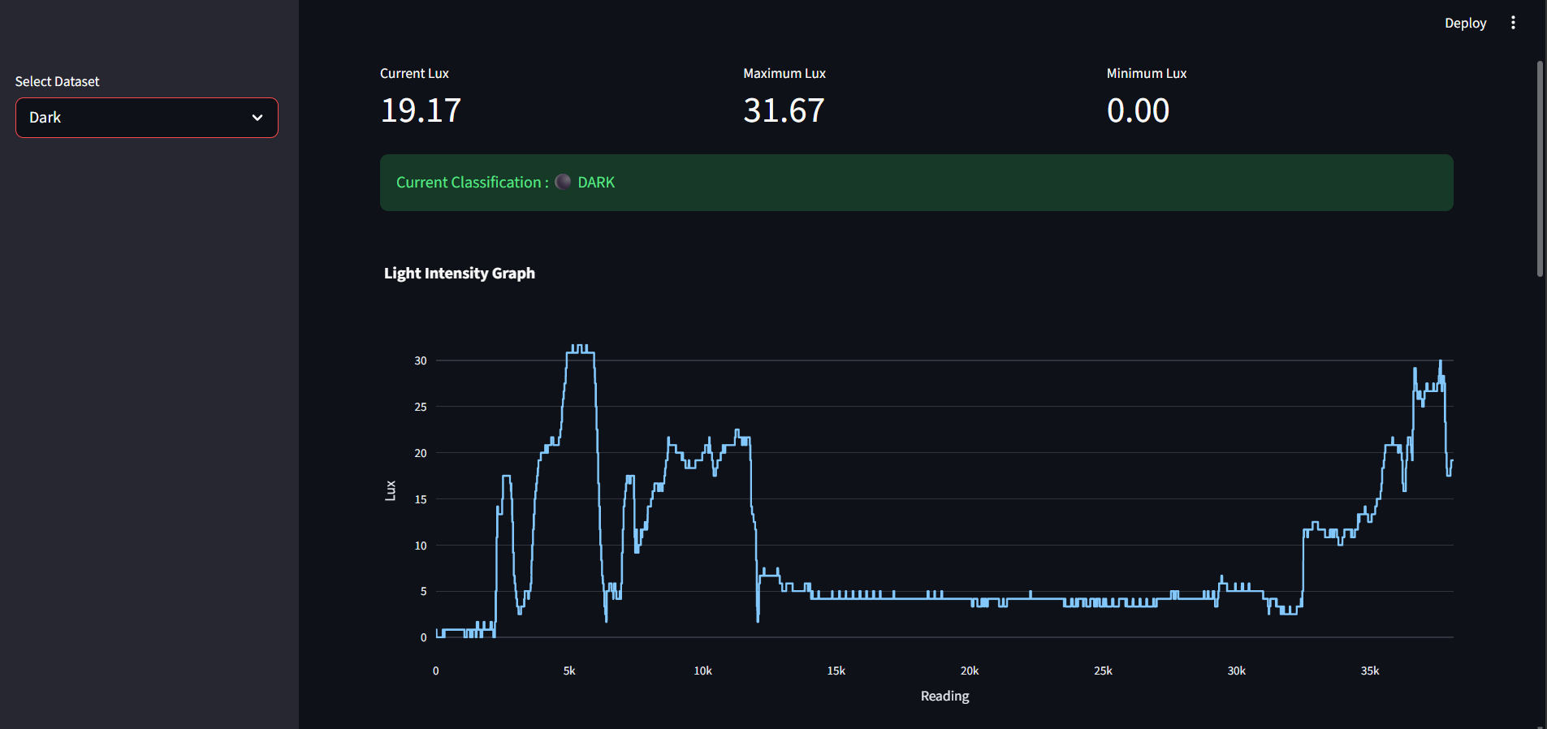
Figure 4. Line graph visualization (Dark)

Observations:
- The dashboard successfully loads each recorded dataset.
- Interactive graphs make it easy to observe changes in light intensity.
- Current lux, minimum and maximum values are displayed instantly.
- The selected dataset is classified correctly as Bright, Dim or Dark.
- The dashboard provides an easy way to visualize previously logged sensor data.

Conclusion:
The Streamlit dashboard successfully visualizes the recorded light intensity datasets obtained from the BH1750 sensor. The application presents sensor readings through interactive graphs and statistical information, making the data easier to understand. This project fulfills the Week 5 objective of converting raw sensor readings into meaningful visual representations for monitoring and analysis.

